**USER MANUAL**

**Login if you have an account:**

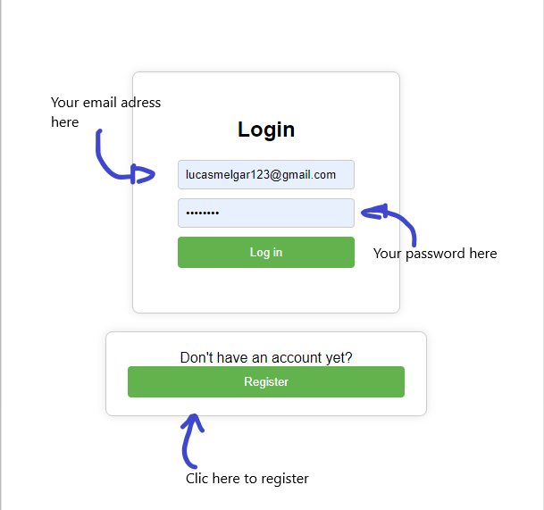

**On this web application, we need your data to make your delivery orders possible and easier:**

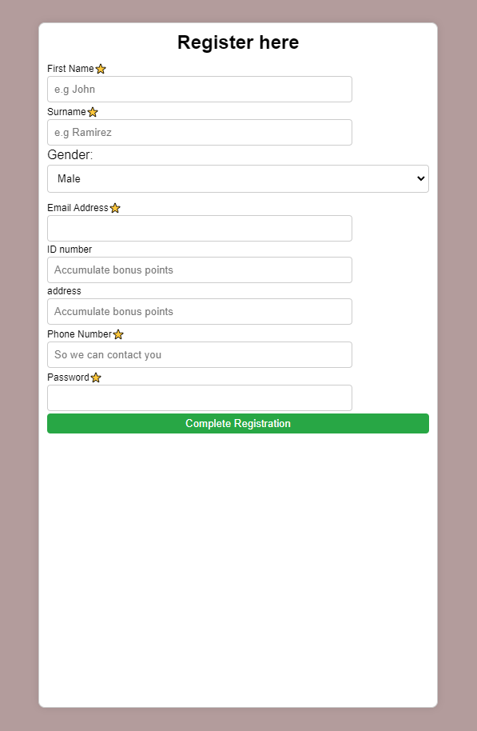

**Once signed up, you’ll be able to select your preferred deal**

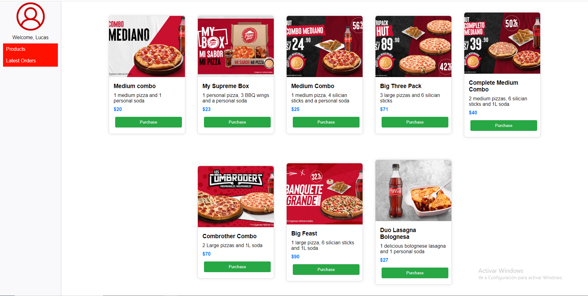

**And select your adress and payment method. (Once clicked on Confirm Order there are no refunds!)**

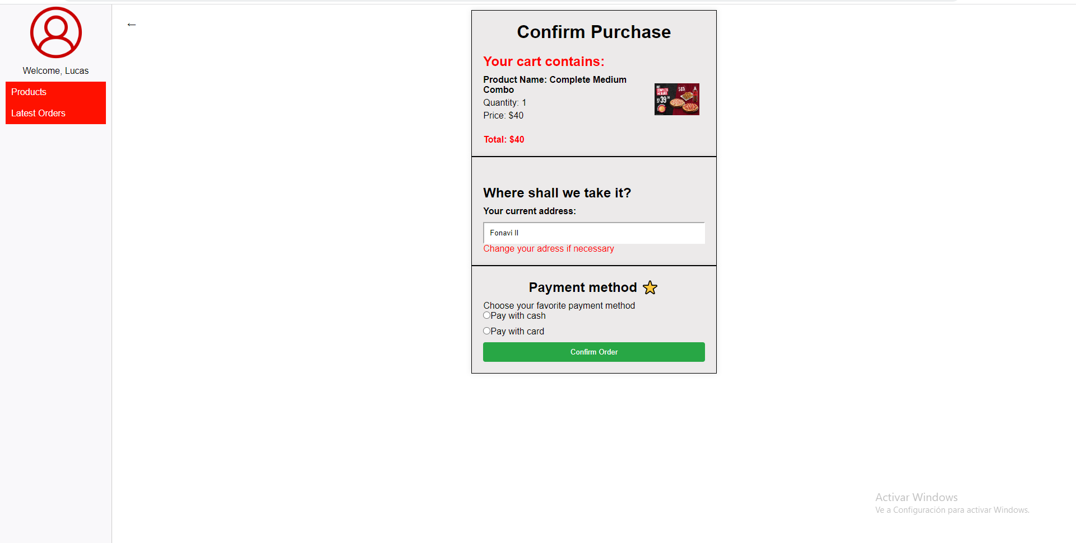

**You can also view your past order by clicking “Latest Orders”**

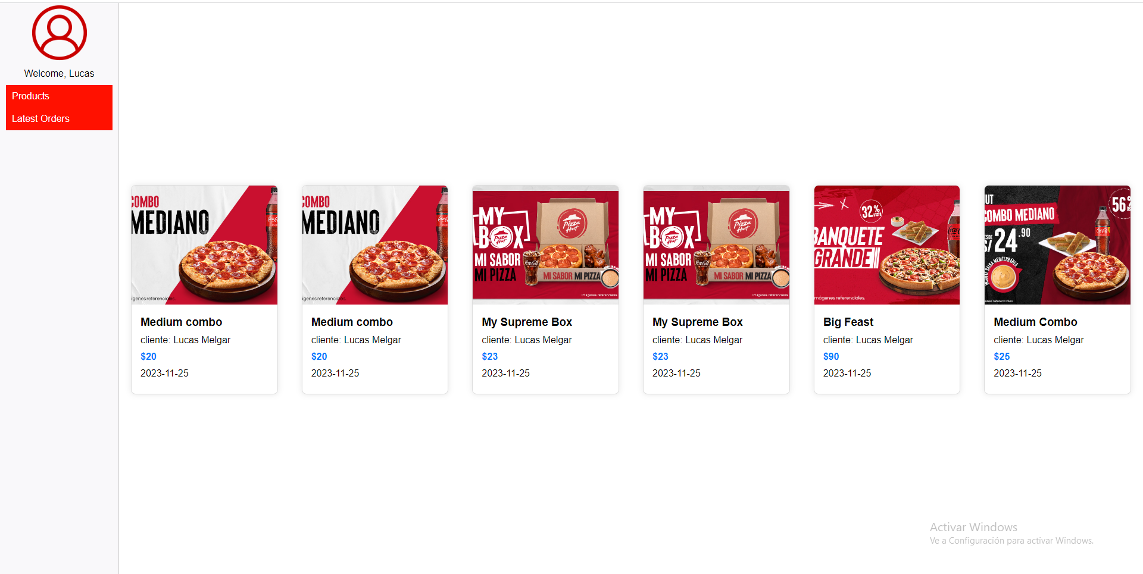

**You can see date of the order**